
Upper Limb Simple Lymphatic Drainage - SLD

Upper Limb Simple Lymphatic Drainage – SLD

This very gentle massage is part of the daily treatment for your swelling. It helps move the fluid from the swollen area to an area that drains more freely. Your clinician will teach you how to do SLD. This leaflet is a step by step guide. There is also a video that you can watch – the link and QR code are at the bottom of this page.

If you are unable to perform the massage by yourself, a partner or carer could help you. If you struggle reaching some areas, try using a roller or a soft long-handled brush.

What to do:
- Massage very slowly and gently. It should take about 15 to 20 minutes to complete
- Massage when you are comfortable, sitting or lying down is best
- Do not press too hard – your skin should not be marked by the pressure you apply
- Creams and oils are not needed. If you are hot and sticky, use a small amount of talcum powder
- Do not massage over an area that is inflamed or infected, including Cellulitis
- If you have any new or unexplained lumps: contact your GP or clinician immediately
- If you have recently finished radiotherapy, you need to wait for 6 weeks before you start the massage over that area

In the diagrams we talk of your unaffected (good) side and affected (bad) side.

Step 1 – Breathing  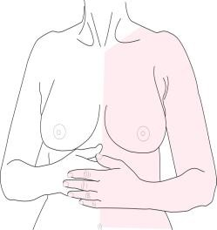  - Sit or lie down with your shoulders relaxed and hands resting below the ribs  - Breathe in and feel your stomach rising (imagine a balloon inflating under your hands)  - Slowly breathe out and press gently inwards with your hands  - Repeat five times |  | 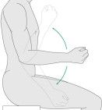  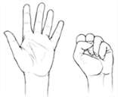  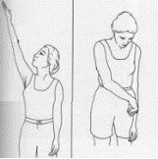  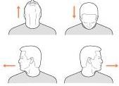  Step 2 – Specific Exercises (10 of each both sides)  - Neck: Look up, then down; look left then right (x5 only)  - Arms: Reach up and out, then cross your arm over your stomach  - Elbows: Bend and straighten  - Wrists: Move up and down  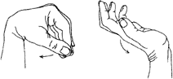  - Hands: Open and close fist
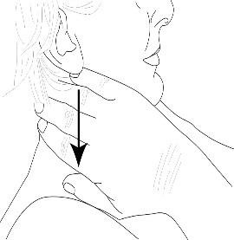  Step 3 - Neck  - Place your hands on both sides of your neck below the ears  - Gently stroke the skin down towards your collarbones and release  - Repeat this movement 10 times |  | Step 4 - Collarbones  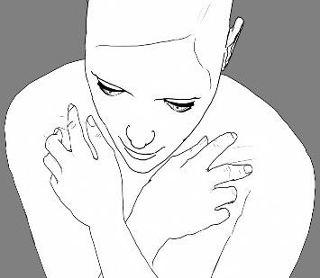  - Place your index finger above, and your middle finger below your collarbone, so that the collarbone lies between these two fingers.  - Gently push downwards and release.  - Repeat 10 times on both sides

n
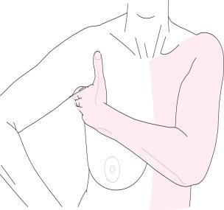  Step 5 - Armpit  - Place your hand in your armpit  - Massage upwards into your armpit and release (10 times)  - Ensure the direction is always upwards  - Repeat on both sides |  | 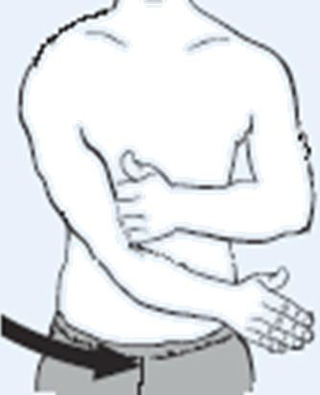  Alternative Method for Step 5  - Place your hand in your armpit  - Cross the other arm across your body towards your opposite hip  - Repeat 10 times on both sides
Step 6 - Chest (unaffected side)  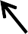  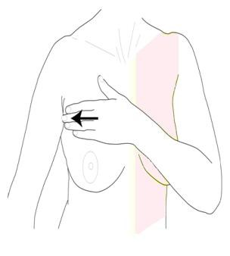  - Place your hand on the unaffected side of your chest  - Stroke across the skin towards your unaffected armpit  - Repeat 10 times, always stroking into the armpit |  | Step 7 – Chest (central)  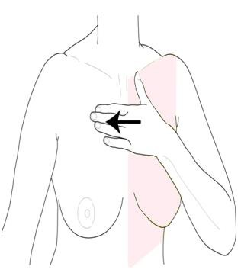  - Place your hand on the middle of your chest  - Stroke the skin towards the unaffected armpit  - Repeat 10 times, always stroking into the armpit  Remember to clear the armpit every now and then
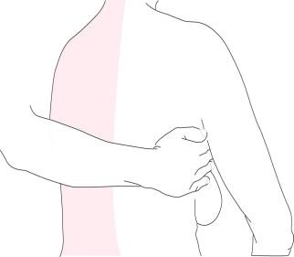  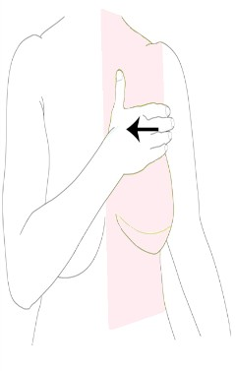  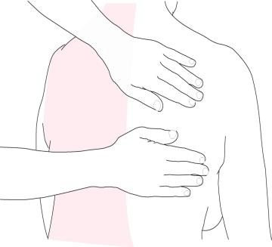  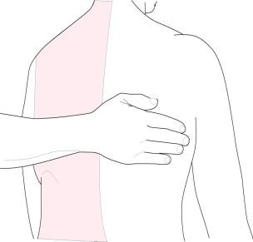  Step 8 – Chest (affected side)  - Place your hand on the affected side of your chest  - Stroke across the skin towards your unaffected armpit  Repeat 10 times, always stroking into the armpit  Remember to clear the armpit every now and then |  | Step 9 – Armpit/Back (with help)  - You can sit or lie down on your front  - Helper places their hand in your unaffected armpit  - Massage upwards into the armpit and release  - Repeat 10 times  - Ensure the direction is always upwards
Step 10 – Back 1 (with help)  - Helper places hand/s on the unaffected side of the back  - Stroke the skin across into the unaffected armpit and release  - Repeat 10 times |  | Step 11 – Back 2 (with help)  - Helper places hand/s on the middle of the back  - Stroke across the ski into the unaffected armpit and release  - Repeat 10 times
Step 12 – Back 3 (with help)  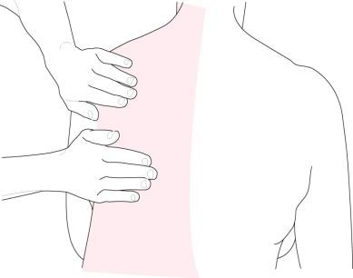  - Helper places hand/s on the affected side of the back  - Stroke across the skin into the unaffected armpit and release  - Repeat 10 times  Remember to clear the armpit every now and then |  | Steps 13 and 14 – Finishing your SLD  Repeat Step 2 – Specific Exercises (10 of each):  - Neck – look up and down, left and right (x5 only)  - Arms – arm up and out, then down and across  - Elbows – bend and straighten elbow  - Wrists – move hand up and down  - Fingers – open and close fist  Repeat Step 1 – Breathing Exercise (5 times)  - Sit or lie down with your shoulders relaxed and hands resting below your ribs  - Breathe in and feel your stomach rising  - Slowly breathe out and press gently inwards with your hands

